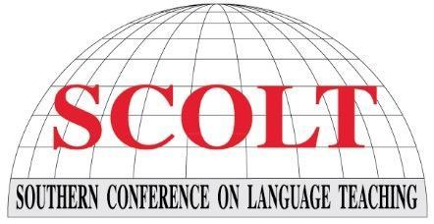

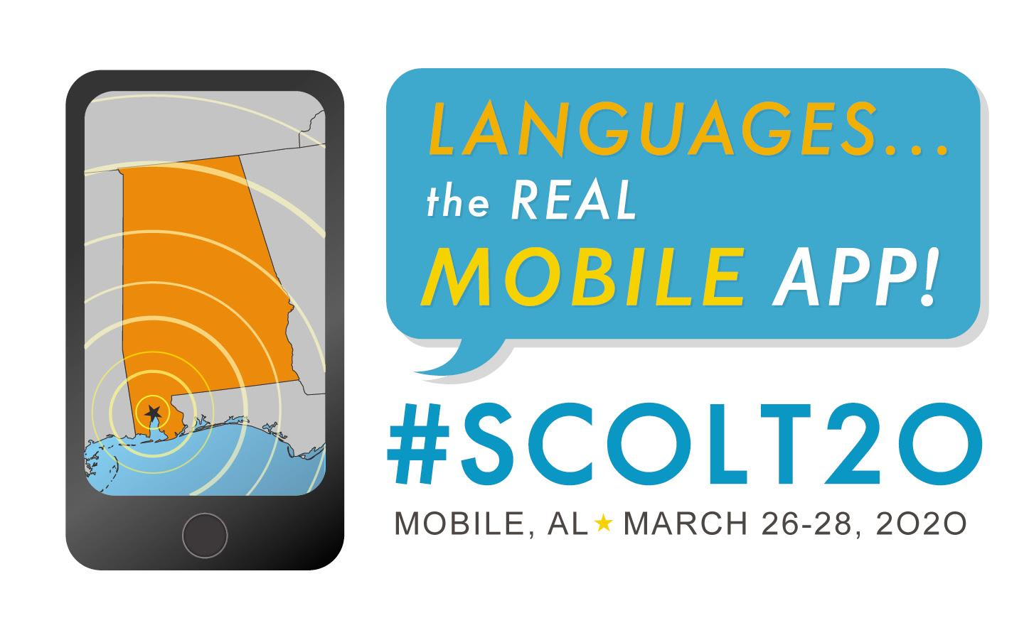
2020 SCOLT Program Cover Contest

The SCOLT 2020 Program Cover Contest is an opportunity for K-12 students to demonstrate their artistic abilities and have their work featured as the cover art of the Conference Program book for the 2020 Annual Conference to be held in Mobile, Alabama.

Contest Details

1. Entry deadline: November 11, 2019. Entries must be postmarked by this date. Late entries will not be considered for judging.

2. Student must be enrolled in a world language class during the 2019-2020 academic year. The sponsoring world language teacher must be a current member of his/her respective state association with dues paid for 2019.

3. All participants will receive a certificate of participation sent via email to the teacher.

4. A teacher may submit a maximum of three (3) drawings per category. The three categories/divisions are:
Grades 3-5
Grades 6-8, and
Grades 9-12.
If a teacher works at multiple schools, s/he may submit one entry per school, or three entries total per category.

5. One drawing will be selected as the 2020 SCOLT Program Cover of the Year. The artist will receive a $50 check and the sponsoring teacher will receive a one-year complimentary SCOLT Sponsor/Patron membership.

6. Entries will be judged on creativity, originality, neatness, and visual impact.

7. All entries will become the property of SCOLT and will not be returned to the student.

8. By entering this contest, the winning student gives SCOLT permission to use his / her entry in any format, including but not limited to the 2020 Conference Program, the SCOLT website, the SCOLT Facebook page, and any social media formats. Further, SCOLT will also include the name of the school and the teacher in conjunction with each appearance of the winning entry.

Artwork Specifications

9. Each drawing must be created by only one student; a drawing by multiple students will not be considered.

10. All entries must be 8 ½” x 11” in size and prepared on a white background. The surface must be flat with no moving parts or additions. Please use cardstock.

11. The design should use a maximum of four colors, including black and white.

12. The art should be done in markers (preferred) or paint. Please do not use charcoal, glitter, or tape on front of the drawing, i.e., no mixed media submissions.

13. Only original artwork may be submitted. No copyrighted figures or photocopied designs may be used.

14. The theme, “Languages: The Real Mobile App!” must be prominently featured in the work (exact wording). Others words are permitted in any language. Note that the word “Mobile” is a play on words, given the location of the conference in “Mobile, Alabama.” See the conference logo at the top right of the previous page.

How to enter the contest

13. The Entry Deadline is November 11, 2019. Entries must be postmarked by this date. Late entries will not be considered for judging.

14. Photo images of the artwork should be taken before submission of the entries, as entries become property of SCOLT and will not be returned.

15. In addition to being mailed to the address below, each individual drawing must also be submitted electronically as a pdf or image file, and be accompanied by the SCOLT Student Entry Form included in this document. Please complete this form and send to Christine Hutchins, Program Cover Contest Chair, at chutchins@stfrancisschool.org.

16. Please mail the artwork first class, FLAT, not rolled or folded and protected by cardboard. Remember to attach the SCOLT Student Entry Form (typed) to the back of the student’s artwork with double-sided tape on all four sides of the form; do not staple the form to the drawing.

17. Mail directly to Christine Hutchins, Program Cover Contest Chair, at 4115 Martha Ave., Louisville, KY 40220.

18. The teacher of winning student will be notified by December 23, 2019.

Student Entry Form

A. Instructions

1. Eligibility: All K-12 students from the SCOLT Region whose sponsoring teacher is a current member of his/her respective state association with dues paid for 2019.

2. Please type your responses to this form with the exception of the Release section.

3. Email 1) this completed form and 2) a pdf copy of your artwork to Christine Hutchins, Program Cover Contest Chair, at chutchins@stfrancisschool.org before midnight on November 11, 2019.

4. Mail the original artwork along with a copy of this form (as specified in the SCOLT Program Cover Contest flyer) to: Christine Hutchins, Program Cover Contest Chair, at 4115 Martha Ave., Louisville, KY 40220.

B. Student Information

Name of Student: Click or tap here to enter text.
School: Click or tap here to enter text.
Grade Level: Click or tap here to enter text.
School physical address: Click or tap here to enter text.

C. Sponsoring Teacher Information

Name of Sponsoring Teacher: Click or tap here to enter text.
Sponsoring Teacher Email: Click or tap here to enter text.
School: Click or tap here to enter text.
School Phone: Click or tap here to enter text.

D. Release

We understand that the drawing entry becomes the sole property of SCOLT and the 2020 SCOLT Program Cover Contest Committee and that the drawing may be duplicated and/or displayed at SCOLT venues. (Please sign and date.)

Student Signature: Date:

Sponsoring Teacher Signature: Date:

Parent Signature: Date:

